**Machine Learning Engineer Nanodegree - Capstone Proposal**

Ju-Ying Chen

[chenjyi@tsmc.com](mailto:chenjyi@tsmc.com)

**Proposal**

I choose the topic “TalkingData AdTracking Fraud Detection Challenge” from Kaggle competition as my final capstone project.

For companies that advertise online, click fraud can happen at an overwhelming volume, resulting in misleading click data and wasted money. An algorithm will be build through the technique of machine learning to predict whether a user will download an app after clicking a mobile app ad.

Most of information can be directly found in the following link:

<https://www.kaggle.com/c/talkingdata-adtracking-fraud-detection>

**Domain Background**

Fraud risk is everywhere, and for companies that advertise online, click fraud can happen at an overwhelming volume, resulting in misleading click data and wasted money. Ad channels can drive up costs by simply clicking on the ad at a large scale.

With over 1 billion smart mobile devices in active use every month, China is the largest mobile market in the world and therefore suffers from huge volumes of fraudulent traffic. TalkingData, China’s largest independent big data service platform. They handle 3 billion clicks per day, of which 90% are potentially fraudulent.

We are challenged to build an algorithm that predicts whether a user will download an app after clicking a mobile app ad. There is a good research, “Detecting Click Fraud in Online Advertising: A Data Mining Approach”, it summarized lots of observations and analyzed the fraud click detection. It also addressed some important issues in data mining and machine learning research, including highly imbalanced distribution of the output variable, heterogeneous data, and noisy patterns with missing and unknown values.

**Problem Statement**

The problem is simple. How to recognize whether a user will really download an app after clicking a mobile app ad? That is, how to distinguish between meaningful clicks and fraud clicks?

TalkingData does have some methods to prevent click fraud, but there are still rooms for improvement. We have to be one step ahead of those fraudsters.

**Data sets and Inputs**

Kaggle competition provides a generous data set covering approximately 200 million clicks over 4 days. All of the necessary data sets can be found and download from:

<https://www.kaggle.com/c/talkingdata-adtracking-fraud-detection/data>

There are around hundreds million recorded data, and each data contains a click record, with 8 features. The 8 features are as following,

• ip: ip address of click.

• app: app id for marketing.

• device: device type id of user mobile phone (e.g., iphone 6 plus, iphone 7, huawei mate 7, etc.)

• os: os version id of user mobile phone

• channel: channel id of mobile ad publisher

• click_time: timestamp of click (UTC)

• attributed_time: if user download the app for after clicking an ad, this is the time of the app download

• is_attributed: the target that is to be predicted, indicating the app was downloaded

Size of the data is really big. It will take much time to use whole training and testing data set due to limited memory. We will split the training data to three pieces, one for training, one for validation and the other for testing. Our final model will be examined by the public Leaderboard of Kaggle.

There is another critical issue that 99.75% of the dataset are labeled as fraud click and only 0.25% is not fraud click. The mobile advertising data are highly imbalanced class distribution. We need to include some data re-sampling strategies for handling this imbalanced label distribution. In the beginning, I will establish a model with the original data. If the model does not pass the cross-validation, I will take the re-sampling of data into account.

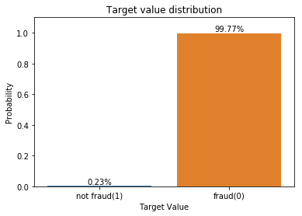

**Solution Statement**

Our model will predict whether a user will download an app after clicking a mobile app ad base on the features of that user. The closer our predictions to truths, the better our model will be. A receiver operating characteristic curve (ROC curve) will evaluate our model’s performance between the predicted probability and the observed target. The amount of wasted money caused by fraudulence will be reduced by distinguishing meaningful clicks and fraud clicks precisely.

**Benchmark Model**

Kaggle competition provides a benchmark model which is developed by a random forest method, and its score is 0.911. Score is evaluated on area under the ROC curve between the predicted probability and the observed target.

**Evaluation Metrics**

Evaluation metric will be the area under the ROC curve between the predicted probability and the observed target. Such metric is also called area under the curve (AUC). AUC of ROC is suitable for a binary classification. Our question is a binary classification problem, that whether a user will download an app after clicking a mobile app or not.

When threshold parameter is T, the data will be assigned to “positive” if X>T, and “negative” otherwise. X follows a probability density f1(x) if the instance actually belongs to class “positive”, and f0(x) if otherwise. Therefore, the true positive rate is given by $TPR\left(T\right)=\int_{T}^{∞}{f_{1}(x)}dx$ and the false positive rate is given by $FPR\left(T\right)=\int_{T}^{∞}{f_{0}(x)}dx$. The ROC curve plots parametrically TPR(T) versus FPR(T) with T as the varying parameter. Then the AUC is simply the area under the ROC. Generally, we can judge our model through the value of AUC like follows:

AUC=0.5 (no discrimination)

0.7≦AUC≦0.8 (a cceptable discrimination)

0.8≦AUC≦0.9 (excellent discrimination)

0.9≦AUC≦1.0 (outstanding discrimination)

Ref: <https://en.wikipedia.org/wiki/Receiver_operating_characteristic>

**Project Design**

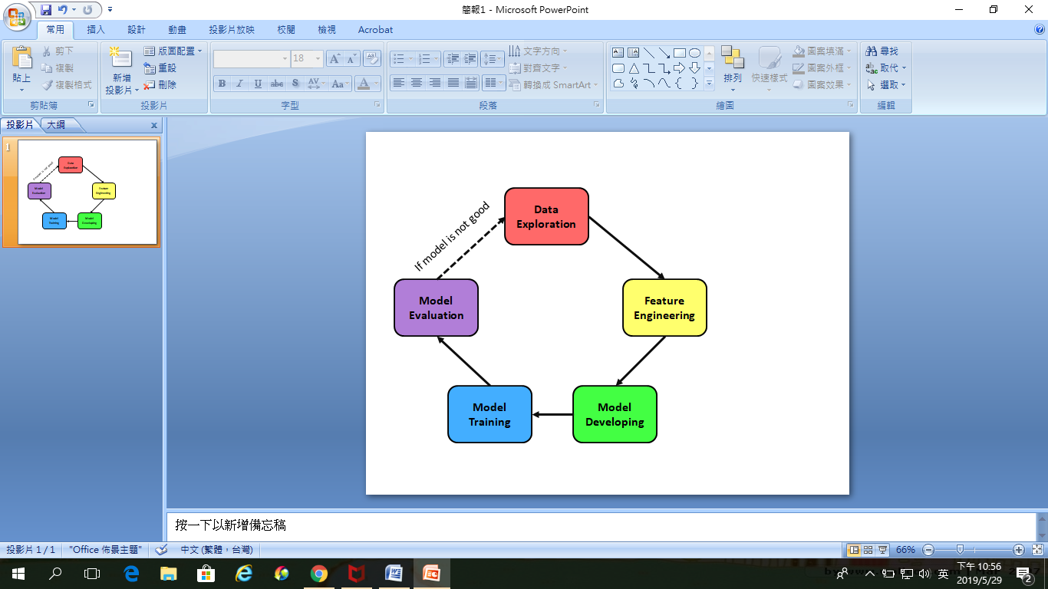

We will follow the working flow fo previous homework. First, we approach this problem by investigating the data. It helps us establish some basic ideas about the property of each feature and the interrelationship between different features. Next, we have to clean the data. Usually, data contains missing value and outliers. We will solve the problem of missing value and outliers, and normalize numeric features.

For developing a proper model for our project, we will split the data set into to three pieces: training, validation and testing. This step is for cross-validation.

Lots of useful algorithms can be our candidate solvers:

• Decision Tree

• Ensemble Methods (Bagging, AdaBoost, Random Forest, Gradient Boosting)

• Neural Network (Multiple Layer Perception) Stochastic Gradient Descent

I will build two kinds of classifiers: one is based on the neural network; the other is based on the random forest.

For the neural network, I will construct 2- 3 fully connected layers and try different activation functions for hidden layers. Then the output layer will be passed through a sigmoid function for converting the output values as probabilities. Other parameters like optimizer and loss function are to be decided.

For the random forest, it is an ensemble learning method which operates by constructing a multitude of decision trees as collecting the contributions from many weak learners. It keeps the advantages of decision tree and makes the final mode more general. That is, with proper parameter setting of each decision trees, random forest can effectively avoid over fitting the training data. Grid search method will be optional for finding the best combination of model’s parameters.

Once we have finished training the models. They will be evaluated by using the evaluation metric, AUC. Models will be check thoroughly to see if there is anything insufficient. Kaggle’s official evaluation will be also taken into account. Depending on the performance of these models, we maybe have to go to some previous step to see if there is anything missing or wrong. Once we have an good model, whose score is at least over 0.92, we can stop and publish that model.

Ref: <https://en.wikipedia.org/wiki/Artificial_neural_network>

Ref: <https://en.wikipedia.org/wiki/Random_forest>